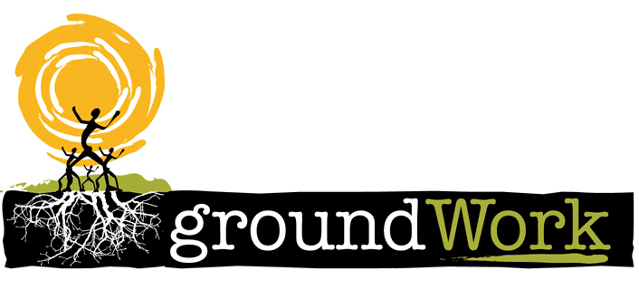 | 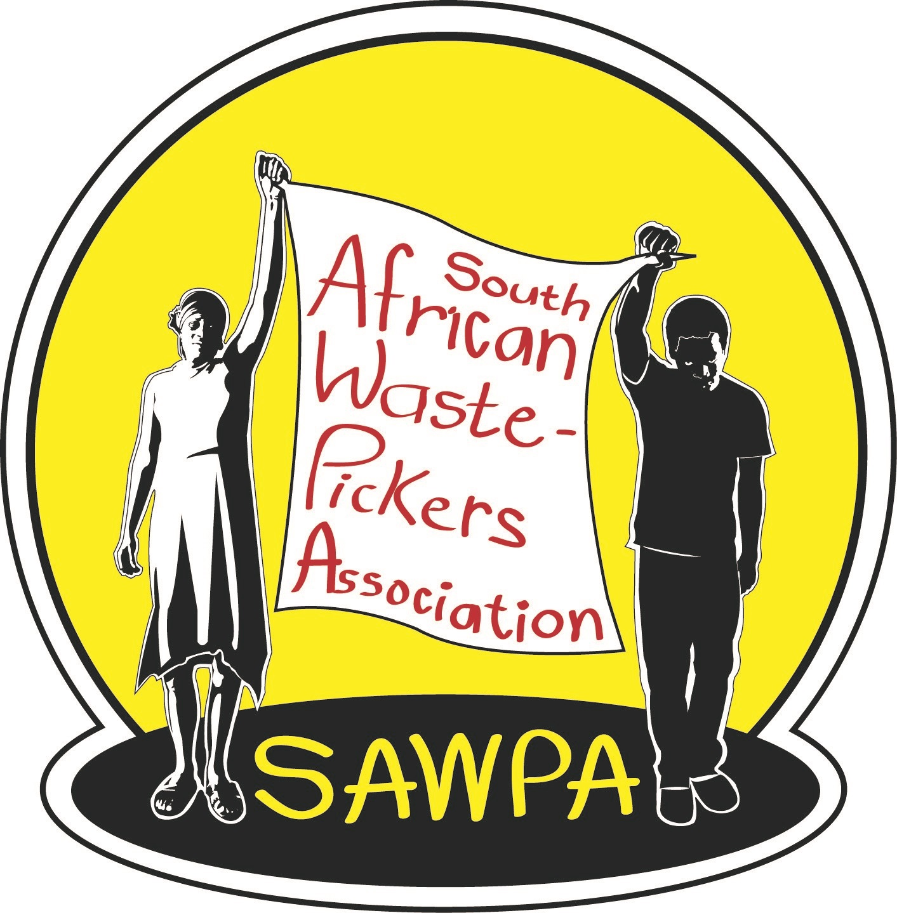
South African Waste Pickers Association and groundWork International Exchange

22nd – 25th August 2017

Gauteng, Free State and KwaZulu Natal landfill and project visits

Arrival: Sunday 21st & Monday 22nd August
Exchange: 22nd August – 25th August 2017

Context

The South African Waste Pickers Association (SAWPA) and groundWork exchange is a platform for Waste Pickers to work together by sharing their stories. The exchange will allow the international visitors to understand current working conditions in South Africa. The international visitors will advise South African waste pickers on the challenges that they have faced in their own struggles. The South African waste pickers will get an opportunity to share their local challenges, a dialogue which will result in an exchange of knowledge and collective empowerment. The exchange seeks to inform and strengthen the global movement of waste pickers.

Objectives of the Exchange:

- Link waste pickers locally and internationally;
- Share strategies on organising locally and internationally;
- Strengthen and broadening the horizon for SAWPA in South Africa and within the global movement of Waste Pickers;
- Visit pilot projects, discuss their observations and what inputs they have;
- Open discussion with government officials on what their countries have done to improve their working conditions.

International solidarity

The exchange comprises of waste pickers from Brazil, India and South Africa. These participants will share experiences of the work they do, the movements they are involved with and show solidarity with SAWPA and its members. They will also share stories of how they work with their own governments with South African government officials at the Phakisa gathering. The international organisations present are:
- National Movement of Collectors of Recyclable Materials (MNCR), Brazil;
- Kagad Kach Patra Kashtakari Panchayat (KKPKP), India.
Participants

South Africa: Simon Mbata (Spokesperson for SAWPA), Mantwa Mokoena (Executive Committee – SAWPA) and Musa Chamane (Waste Campaigner – groundWork).
Brazil: Severino Lima (Jnr) (Founding member – MNCR).
India: Sonali Kunjir and Nirmala Kokane (KPPKP).

Operation Phakisa Waste Minimisation plan

There are two formal meetings that we will attend during this exchange. There is a government operation Phakisa meeting which is ongoing, and aims to minimise waste and unlock economic opportunities presented by waste. The aim of the plan it to fast track waste projects in various municipalities so that waste contributes meaningfully to the South African Economy. There are various experts, academics, business, government sectors representatives who are in a 5-week long strategic planning meeting with the aim of developing a detailed delivery plan for enhancing the waste economy of South Africa. Therefore ideas, dialogue, plans, proposals are being presented so that the plan can be adopted.

Gauteng Province

Onderstepoort: Domestic and non-hazardous Industrial Waste
The Onderstepoort landfill site is in Pretoria (Tshwane Municipality). This landfill has 5 registered cooperatives; Yebo Rekopane Recyclers, Ga-rankuwa Recycling, Somandla Recycling, Onderstepoort Recycling and Pretoria Noord Recycling. To date, only Yebo Rekopane Recycling Cooperative has benefitted in the cooperative incentives schemes provided for by the Department of Trade and Industry. Through this scheme they have acquired a truck and a bailing machine. The challenge they’re facing is that they don’t have a space to work next to the landfill to store their tools. This site is located on the west of Pretoria. It has about 200 waste pickers working on this site.

Kwaggasrand: Closed
This landfill closed in 2015 and waste pickers were ordered by City of Tshwane to go and work in other landfills in Pretoria. The Tshwane Municipality decided to enter into a public private partnership (PPP) with GX Enviro Solutions Logistics Holdings (Pty) Ltd. The municipality and the company promised 261 jobs to waste pickers by the city of Tshwane, and waste pickers were told to go and work at other Tshwane council landfills while construction was in progress. The MRF is still under construction. The Tshwane Municipality and the company has not started talking with the ex-waste pickers of the site about the promised jobs. There is a general fear that the jobs at the MRF might be reserved for people who are politically linked and who have no experience in waste.

Marie Louise: Domestic and non-hazardous Industrial Waste
The Marie Louise landfill is in Dobsonville, Soweto. It is operated by Pikitup and is one of the oldest landfill sites in Johannesburg. Here waste pickers are divided in terms of the shifts, with the morning shift for South Africans and afternoon shift for non-South Africans. The waste pickers on this site are legally allowed to work following a court case they won back in early 2000s.

Goudkoppies: Domestic and non-hazardous Industrial Waste
The Goudkoppies landfill is situated on the outskirts of Johannesburg and is also managed by Pikitup. The landfill has a Materials Recovery Facility which is not operational and waste pickers want to use the MRF, but are not allowed. The waste pickers on this site are organised and have committees that deal with waste picker governance and related issues.

Free State

Fezile Dabi District Municipality
Sasolburg District Municipality is hosting a strategic meeting on recycling. They have requested that the delegation of waste pickers could come and discuss challenges that they are facing with regard to recycling in this region. The waste manager at the district municipality has assisted the waste pickers who used to be based at the Sasolburg landfill to acquire the right to use Vaal Park Recycling Centre which used to be a refuse garden site. This meeting will be mainly for the cooperatives of waste pickers working at Fezile Dabi District Municipality. We will have people from business as well as government officials who will be part of the meeting. In this meeting we hope ideas will be shared and questions will be asked and answered by the delegation and by anybody who will be part of the meeting.

Vaal Park Recycling Centre
Vaalpark recycling centre used to be a garden refuse site for the Vaal Park suburb in Sasolburg. The leadership of SAWPA together with industry visited Brazil in 2011 and they had meetings with Municipalities there together with MNCR. There were lessons learned by South Africans who agreed to come back and start a project in South Africa. Sasolburg Vaal Park project came as a result of negotiations between the industry, municipality, and waste pickers. The Ikageng Ditamatieng Cooperative, a registered association formed by waste pickers on Sasolburg dump, runs the new Recycling Centre, which opened in November 2014. This is a separation at source project and the waste pickers’ truck collects from each and every house in Vaal Park. The centre employs 10 waste pickers who used to be based at the Sasolburg landfill. The centre does not only sell the materials that they receive, some materials that are reparable and re-usable are sometimes donated back to communities. The cooperative works with all levels of government and induistry.

The recycling project is currently being expanded, with hundreds more household bins being distributed in surrounding communities. This is backed by an awareness campaign so people understand the environmental and community benefit of recycling. To this end, the Centre has secured a weekly 30-minute spot on the community radio. Awareness events are also held in public areas (such as parking lots), where the workers hand out brochures and explain the value of their work.

KwaZulu Natal

New England Landfill Site: Domestic and non-hazardous Industrial Waste
The MSunduzi Municipality operates the New England Road landfill. It is a poorly managed site, and is in transgression of a number of its permit conditions. Waste pickers have had a contentious relationship with the Msunduzi Municipality and the Mayor of the Municipality has in the past ordered them to be shot. Twenty one million rands was set aside for a Materials Recovery Facility (MRF) to be built but the politics between the district and local municipality prevented the construction of the MRF. Waste pickers are organised here under the Hlanganani Ma-Afrika Recycling Cooperative.

Mooi River Landfill site: Domestic and non-hazardous Industrial Waste
At the Mooi River landfill site, the Mooi River Recycling Cooperative operate a recycling facility. The municipality built an MRF and this was handed over to the waste pickers in Mooi River who formed a cooperative of 10 members. The MRF is managed and operated by the cooperative and employs 15 people who are picking waste and bailing it and selling it to the market. This site shows how government could assist waste pickers in general in all municipalities in South Africa.

Day 01: 22nd August 2017
Time | Activity | Where
08:00 – 09:00 | Welcome, Introductions and briefing | Elijah Barayi
09:00 – 13:00 | Operation Phakisa: Waste Minimisation | Magaliesburg, Mt Greys
13:00 – 15:00 | Lunch – on the Road
15:00 – 16:00 | Onderstepoort landfill visit in Pretoria | Onderstepoort landfill
16:00 – 16:30 | Discussion Questions to be developed | Elijah Barayi

Day 02: 23rd August 2017
Time | Activity | Where
08:00 – 09:30 | Travel to Sasolburg | Midrand to Sasolburg
09:30 – 13:00 | Sasolburg meeting | Sasolburg
13:00 – 14:00 | Lunch
14:00 – 16:30 | Vaalpark project | Sasolburg

Day 03: 24 August 2017
Time | Activity | Where
08:00 – 09:00 | Travel to Johannesburg | Sasolburg to JHB
09:00 – 11:00 | Landfill visit | Goudkoppies Landfill
11:00 – 12:00 | Travel to next site
12:00 – 13:30 | Landfill Meeting | Marie Louise Landfill
13:30 – 15:30 | Lunch & Travel to Airport
15:30 – | Fly to PMB or DBN | O R Tambo International

Day 04: 25 August 2017
Time | Activity | Where
09:30 – 10:30 | PMB landfill visit | PMB
11:30 – 13:00 | Mooi River Project | Mooi River
13:00 – 14:00 | Lunch | Rawdons
14:00 – | groundWork Office | PMB

