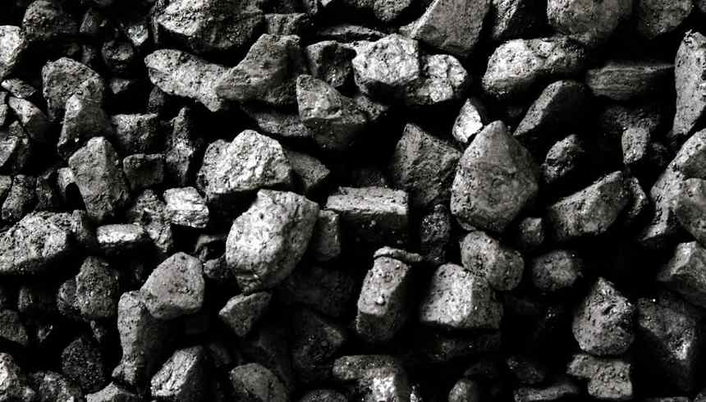
Coal & Uranium
6 NOVEMBER 2017

Coal-fired power plant developer keeps boxing gloves on

A coal power developer hopes to win a court battle to allow it to build a coal-fired power station without first having its environmental approval reconsidered.
Despite a clear ruling by the Pretoria High Court earlier this year on the need for climate impacts to be considered prior to authorisation of a coal power plant, another independent coal power developer hopes to win a court battle to allow it to build a coal-fired power station without first having its environmental approval reconsidered with a comprehensive climate impact assessment.
In August 2017, Environmental justice organisation groundWork, represented by the Centre for Environmental Rights, instituted court proceedings to set aside the environmental approval given by the Department of Environmental Affairs to Kuyasa Mining on behalf of KiPower, citing the authoritative court judgement by the Pretoria High Court in the Thabametsi coal power plant case in March 2017.
In September 2017, KiPower and Kuyasa withdrew their opposition to review of the environmental authorisation, indicating that they would be applying afresh for an environmental authorisation for the project.
However, on 18 October 2017, KiPower and Kuyasa gave notice that they now again intend to oppose groundWork’s court challenge.
The particular technology KiPower proposes using in the power plant would result in unacceptably high greenhouse gas emissions – as Thabametsi’s climate change impact assessment has shown.
These significant climate impacts cannot be substantially mitigated.
groundWork and the Centre for Environmental Rights, along with environmental justice organisation Earthlife Africa Johannesburg, are part of the Life After Coal/Impilo Ngaphandle Kwamalahle campaign.
This is a joint campaign which aims to discourage investment in new coal-fired power stations and mines; accelerate the retirement of South Africa’s infrastructure; and enable a just transition to renewable energy systems for the people.
Feature image credit: Wikimedia
https://www.miningreview.com/news/coal-fired-power-plant-developer-keeps-boxing-gloves/

